Create a castle based on a floorplan.
SWBAT: Create a building following using a floorplan background image and use the Boolean modifier to add details into the castle.

In this lesson we are going to learn how to use background images such as a floorplan or schematic to create a 3d model of a castle. We will also use Boolean modifiers in order to cut windows and other shapes into our castle
Part 1: Matching up the floorplan
Open up blender delete the default cube by pressing X

Next, press n to toggle an additional options panel on the right.
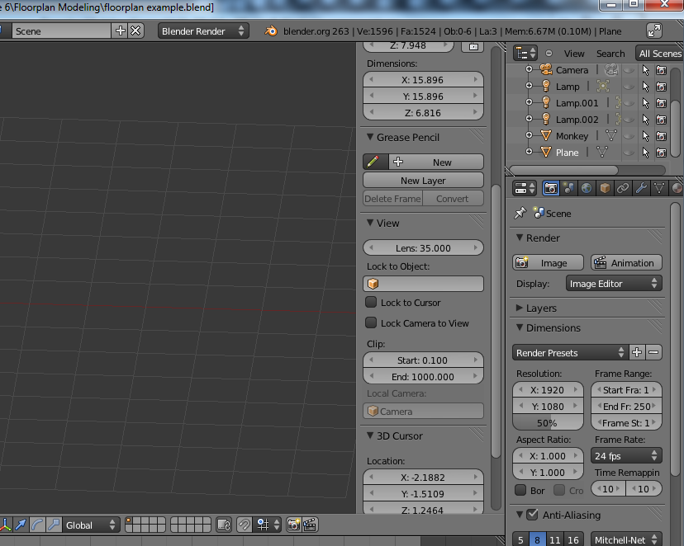
Scroll down to the bottom of this panel and put a check mark in background images and click add image. The goal is to match flat surfaces to the floorplan and then extruding these faces upwards.
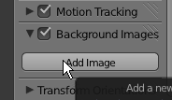
Click open
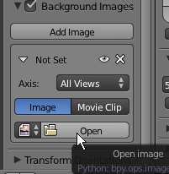
Look inside your Desktop/Lesson Documents/Floorplan Modeling/ and find the floorplan.jpg
Select floorplan.jpg and click open image.
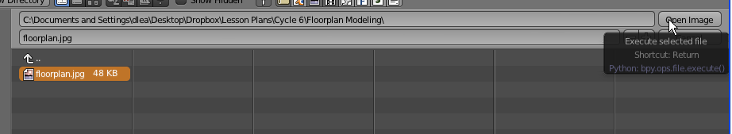
Click on image axis and select top. This will make the image appear only when we are in top orthographic view.
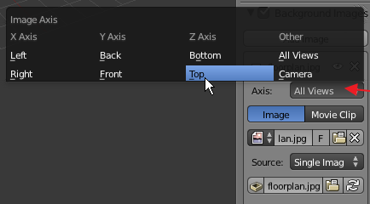
Press num 5 to turn on orthographic view. Press num 7 to view from the top. Use shift + middle click to move around without changing the view point. Scroll the mousewheel to zoom in and out
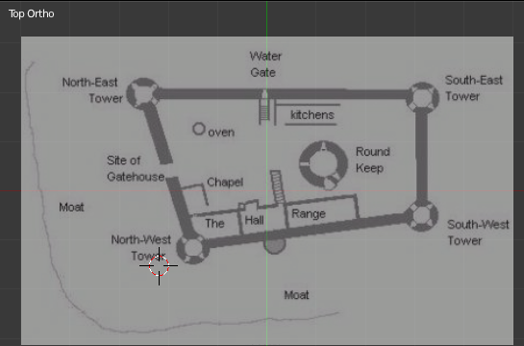
Press Shift +A to add circles for one of the towers. Move it into place and press s to scale down the circle to fit.
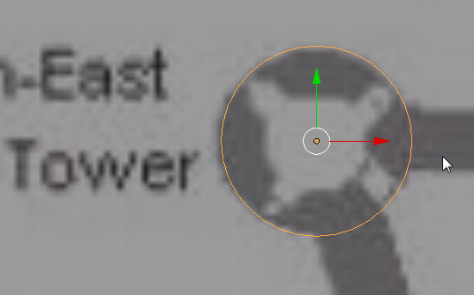
Press Shift + D to duplicate the circles for each of the towers.
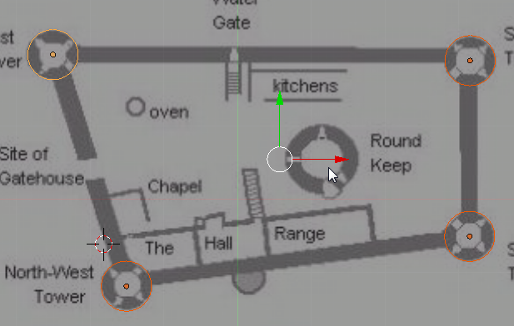
Shift+ A to add a plane. Press S to scale the plane down to fit the width of the wall sta.
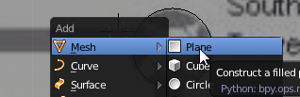
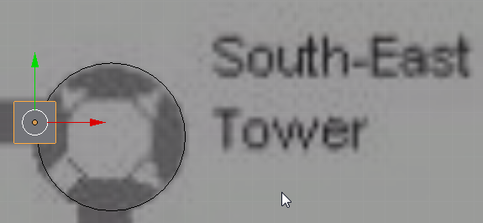
Then Tab to go into edit mode and use edge Selection mode.
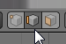
Grab the left edge and move it to the next tower.
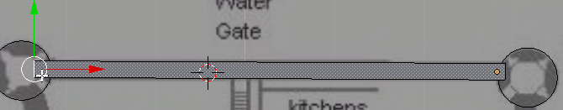
Press E to extrude another face.
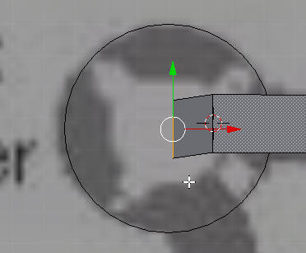
Now press E again and extend a face to the next wall. Press R to rotate the face to line up with the wall
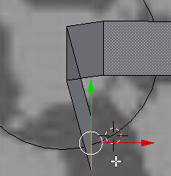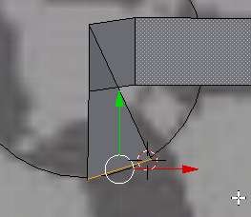
Press E and extrude till you reach the next tower.
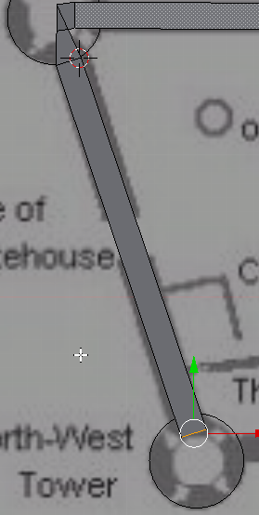
Repeat these steps until you have gone around the entire perimeter of the wall.
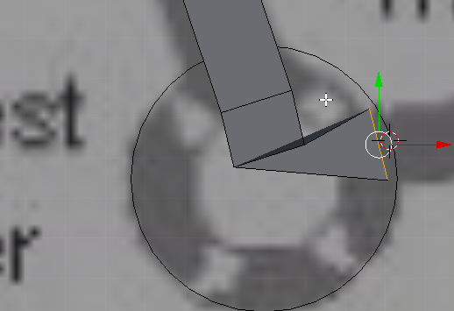
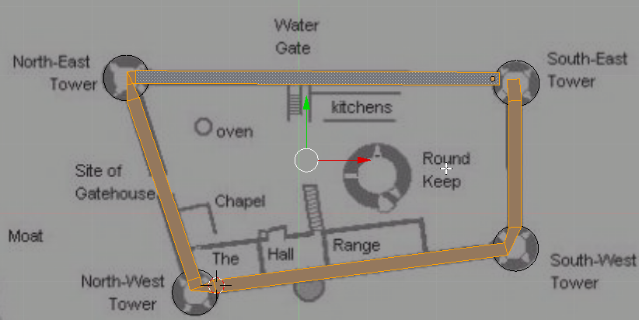
Part 2:Extrusion
Now for the interesting part, we are going to extrude the wall and towers separately. You should have something like this from the previous section.
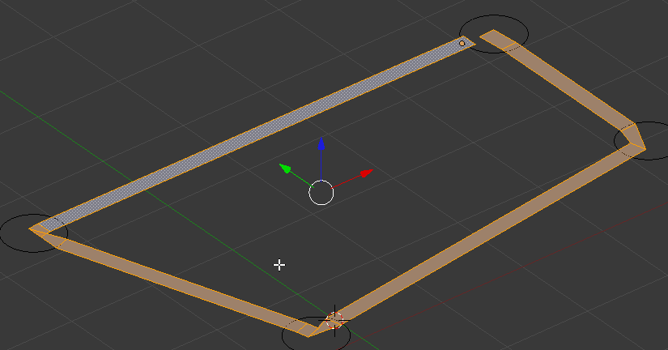
Go into face selection mode.
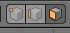
Press E to extrude the wall
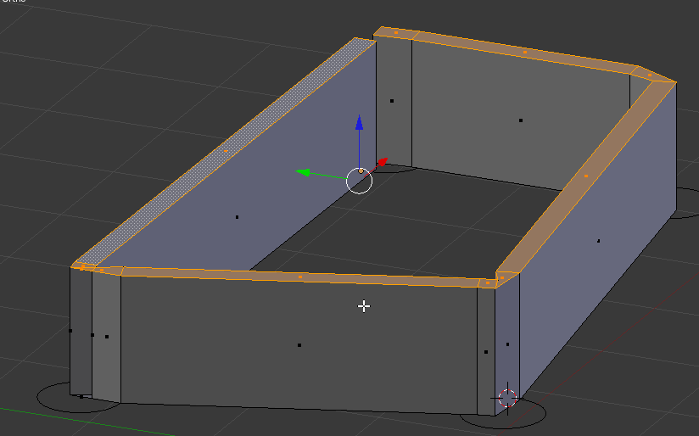
We will add details to the wall later but for right now we are going to make the towers.
Press tab to enter back into object mode.
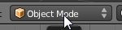
Right click to select the circle and press tab to enter edit mode.
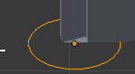
Press A to select all then press F to fill the circle
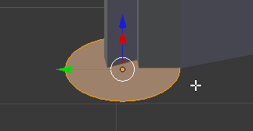
Press E to extrude circle.
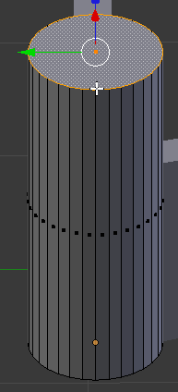
Press E again and press escape. Then press S to scale the tower.
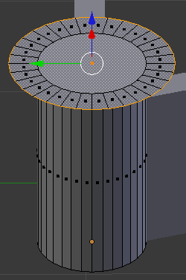
Press E and move down to create the castle tower.
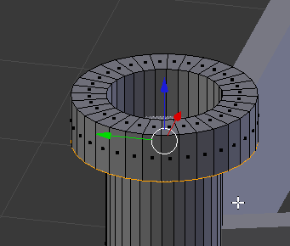
Right click on one of the top faces of the tower. Then hold shift and click on every other face.
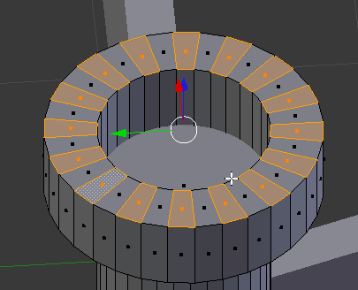
Press E to extend the faces.
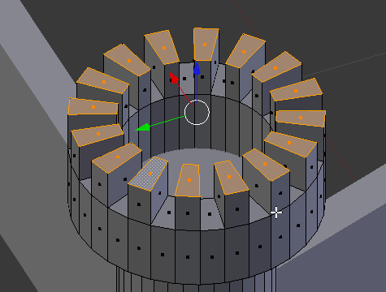
Press TAB to go back into object mode and repeat for each tower.
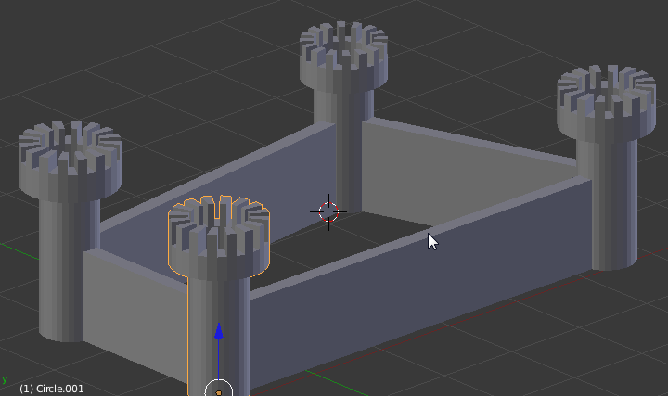
Now we make the wall, select the wall and press TAB to enter edit mode.
Then press Ctri+R to create edge loops. Move your mouse around one of the towers till you have a loop that goes around the top edge of the wall. Then roll your mousewheel until you get 3 edge loops. Left click to confirm.
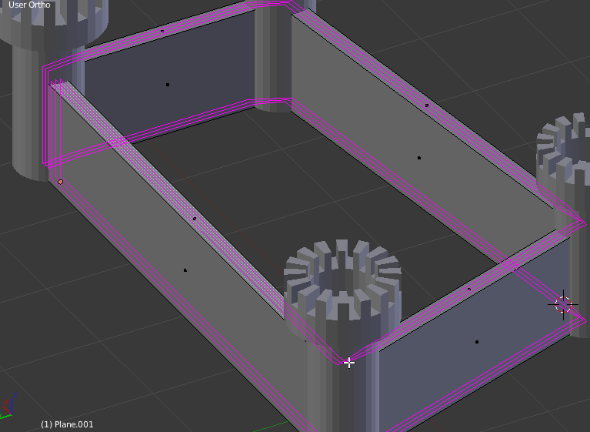
Now we are going to cut the around the wall. Ctrl+R to make the edge loop cuts and roll your mousewheel until you have a good number of wall sections (you will have to make your own judgement). Left click to confirm the cuts.
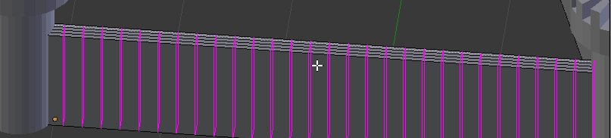
Next Keep doing this until you have cut up every wall.
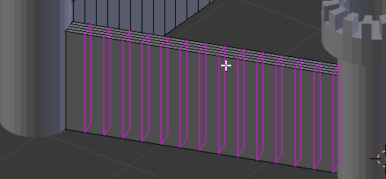
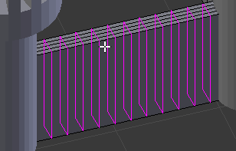
Now use Shift + Right click to select the faces along the edges of the wall.
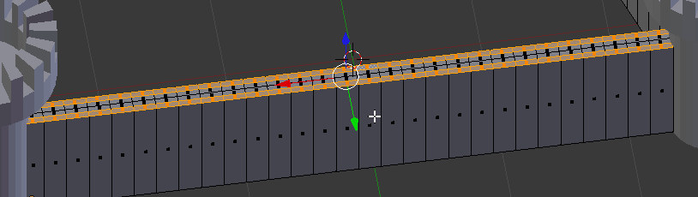
Press E to make a short extrusion.
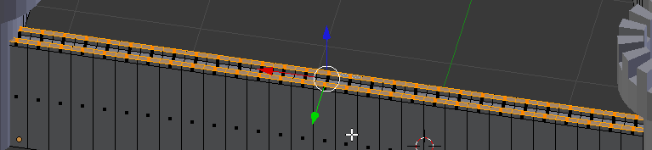
Shift + Right click to deselect every other face.
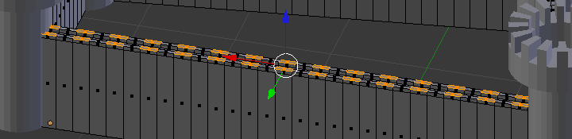
Press E to extrude the faces.
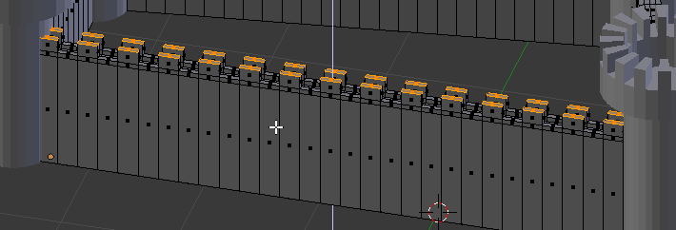
Repeat for each wall.
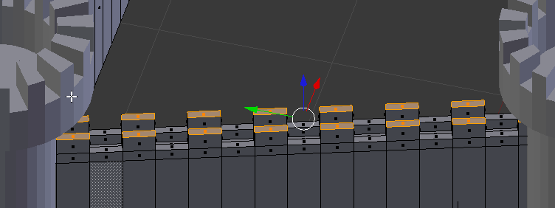
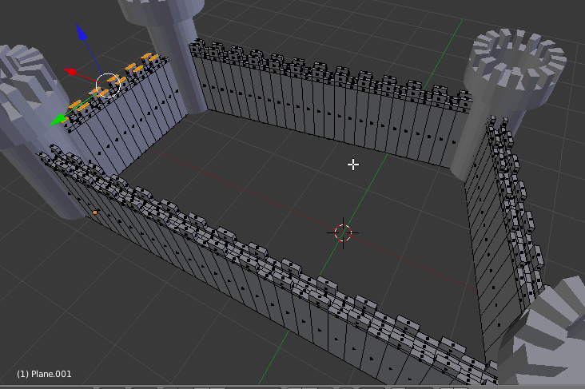
Press tab to get back into object mode.
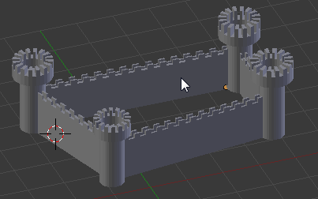
Part 3: Adding ground and rendering.
When you are done, press Shift + A and add a plane.
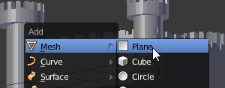
Move the plane so that it is level with the castle. Then press S to scale the plane to make it wider than the castle.
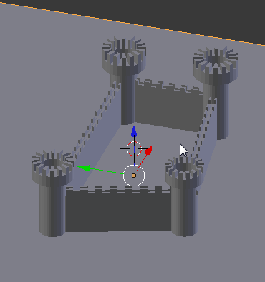
You can add lights by pressing Shift + A and selecting lamp>point
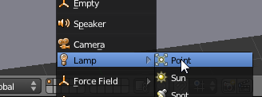
Add a few lights until the castle is lit from all sides.
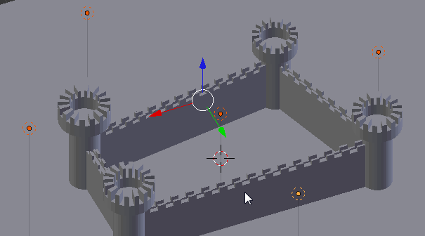
Now move your camera around until you can see the castle, the camera can be moved just like any other object. Press Num0 to look through the camera.
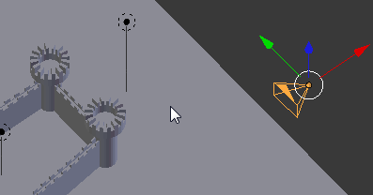
While looking the camera press R twice to rotate your view until you see the castle.
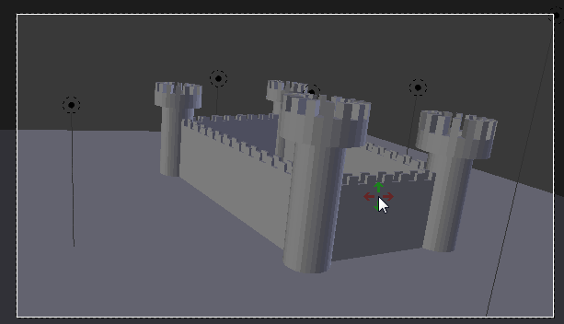
Press F12 to render. Press ESC if you need to exit render view.
